AMBLER PHYSICAL THERAPY & SPORTS REHABILITATION, LLC.,
45 Forest Ave., Ambler, PA, 19002
Phone 215.643.9250, fax 215.643.9251

Please provide us with important background information to ensure a thorough examination. If you have any questions, please leave that question blank and the therapist will assist you with answering it.
NAME:_____________________________________________DATE:__________________________________
ADDRESS:__________________________________________________________________________________
TELEPHONE #: HOME:___________________ CELL:______________________ WORK:___________________
DATE OF BIRTH:___________________________ AGE:____________ MALE:_________ FEMALE:__________
MARITAL STATUS (circle one): M S D SEP W IF MARRIED, SPOUSE’s NAME:__________________________
Highest Level of Education:______________________ SPOUSE’s Date of Birth:____________________
OCCUPATION:________________________LEISURE ACTIVITIES:______________________________________
Please check any of the following whose care you are under.
____Medical Doctor ____ Osteopath ____Dentist ____Psychiatrist/Psychologist ____Physical Therapist ____Chiropractor Other: ______________________ Date of last examination: __________________________
If you have seen any of the above during the past 3 months, please describe for what reason (e.g. Illness, Medical Condition, Physical) __________________________________________________________________
__________________________________________________________________________________________
Please state your primary complaint for coming to the office today?___________________________________
__________________________________________________________________________________________
Have you EVER been diagnosed as having any of the following conditions?
YES NO ALLERGIES: List any medication allergies:_________________________________________
YES NO Latex Sensitivity
YES NO Cancer If yes, what kind?_______________________________________________________
YES NO Heart problems YES NO Chemical dependency (e.g. alcoholism, drugs)
YES NO High Blood Pressure YES NO Multiple Sclerosis
YES NO Osteoporosis YES NO Rheumatoid arthritis
YES NO Asthma YES NO Osteoarthritis If so, where: ____________________
YES NO Emphysema YES NO Depression
YES NO Bronchitis YES NO Hepatitis
YES NO Epilepsy/Seizures YES NO High Cholesterol
YES NO Thyroid problems YES NO Stroke
YES NO Diabetes YES NO Kidney Disease If so, what kind:__________
YES NO Tuberculosis YES NO Blood Clots
YES NO Circulatory problems YES NO Other Arthritic Conditions YES NO Other:_____________________________________________________________________________

Please list any injuries, like fractures, dislocations or sprains, for which you have been treated, and the approximate date of the injury. ________________________________________________________________
__________________________________________________________________________________________

During the past month, have you been feeling down, depressed, or had little interest or pleasure in doing things? YES NO
Do you ever feel unsafe at home or has anyone hit you or tried to injure you in any way? YES NO
Have you ever been threatened or hurt or made to feel afraid or humiliated by your partner or someone else close to you? YES NO
For women: Are you currently pregnant or do you think you might be pregnant? YES NO

Please list any surgeries or other conditions for which you have been hospitalized, and the approximate date of the hospitalization.:

Please circle the conditions listed below for which your immediate family has been treated.
Diabetes Stroke Kidney Disease Tuberculosis Cancer Inflammatory Arthritis Osteoporosis
Anemia Heart Disease Headaches Epilepsy Mental Illness High Blood Pressure
Alcoholism (chemical dependency) Other:______________________________________________________

Please circle any Over-The-Counter medications you have taken in the past week, if any:
Aspirin Tylenol Advil/Motrin/Alleve Decongestants Antihistamines
Antacids (Tums, Zantac, Pepcid) Vitamins/Supplements Other:_________________________

Please list any Prescription medication you are currently taking. Include pills, injections and skin patches. Please list dose, frequency and why you are taking that medication.

How many cups of caffeinated beverages (coffee, tea, soda) do you drink a day? ________
Do you smoke? YES NO If yes, how many packs do you smoke per day? ______________
Do you drink alcohol? YES NO If yes, how many days per week do you drink? __________
Using a scale of 1 drink = 12 oz. of beer, 5 oz. of wine, or 1 shot of liquor, how many drinks do you drink during an average day? _________

Have you recently noted:
Weight Loss/Gain YES NO Fatigue/Weakness YES NO Dizziness/Light-headedness YES NO
Fever/Sweats/Chills YES NO Nausea/Vomiting YES NO Numbness/Tingling YES NO
Double Vision/Loss of Vision YES NO Skin Rash YES NO Trouble Sleeping YES NO
Sexual Difficulties YES NO Recently Fallen Down YES NO Easy Bruising/Excessive Bleeding YES NO
Heart racing in your chest YES NO Difficulty swallowing YES NO Heartburn/Indigestion YES NO
Constipation/Diarrhea YES NO Blood in stool YES NO Problems Urinating YES NO Tremors YES NO

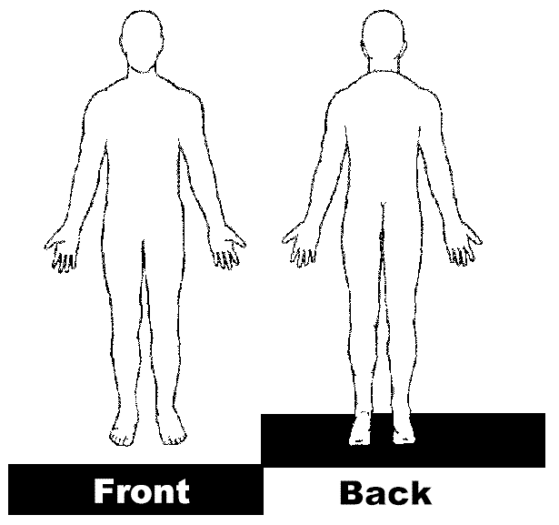
What is the primary reason today’s appointment?
________________________________________________________
________________________________________________________

When did this condition start?
Please mark the body map to the right where you have symptoms.

Insurance Information:
Is your injury a result of an accident YES___ NO____
If yes, Date of Accident: ____________________ State of Accident:_________________
Was accident: Auto ________ Work __________ Other: _________________________
Have you filed an application for benefits with the insurance company? YES____ NO____
Do you have an Attorney? YES _______ NO __________

Primary Insurance Company Name________________________________________________________
ID #:______________________________________ Group #: ___________________________________
Subscriber or Policyholder Name:_______________________________ DOB: _____________________
Secondary Insurance Company Name:______________________________________________________
ID#:___________________________________ Group #:_______________________________________
Subscriber Name: ____________________________________________ DOB: _____________________

Patient Releases
I hereby authorize Ambler Physical Therapy & Sports Rehabilitation, LLC through it’s appropriate personnel to provide me with physical therapy examination and treatment procedures.

I hereby authorize Ambler Physical Therapy & Sports Rehabilitation, LLC to furnish the above-named Insurance company(s) with any medical information regarding this injury that may be necessary to process all claims relative to the physical therapy received.

I hereby request that payment of authorized insurance benefits for the physical therapy services I receive by Ambler Physical Therapy & Sports Rehabilitation, LLC be made on my behalf directly to Ambler Physical Therapy & Sports Rehabilitation, LLC.

I understand that I am legally responsible for any charges for physical therapy services received at Ambler Physical Therapy & Sports Rehabilitation, LLC which are unpaid by my insurance coverage and denied by them to be my responsibility to pay. Such charges may include, but are not limited to: denied coverage, deductible amounts, co-insurance amounts, and non-covered items.

I hereby initiated and authorize my participation of e-visits and televisits with Ambler Physical Therapy & Sports Rehabilitation, LLC.

I have answered the above information to the best of my knowledge. I understand all information provided by any member of the Ambler Physical Therapy & Sports Rehabilitation, LLC staff regarding my insurance coverage is not a guarantee of my medical benefits. I will not hold Ambler Physical Therapy & Sports Rehabilitation, LLC responsible for any misinformation they may receive from my insurance company regarding coverage for out-patient physical therapy care. I have been advised to contact my insurance company directly to verify my benefits for outpatient physical therapy care.

A photocopy of the above releases shall be considered as effective as the original.

_________________________________________ _________________________________________
Patient signature Date Therapists signature Date

Dianne Miller, PT
Ambler Physical Therapy & Sports Rehabilitation is an out-patient facility. I rent space from my local senior center but treat all ages. I treat mostly orthopedics but with some of my older patient’s I will work with some neurologic diagnoses and balance disorders.

